Sprint 1 - Endurance Design Document

March 23, 2023

Table of Contents

1. Executive Summary 2

1.1 Project Overview 2

1.2 Purpose and Scope of this Specification 2

2. Product/Service Description 2

2.1 Product Context 2

2.2 User Characteristics 2

2.3 Assumptions 3

2.4 Constraints 3

2.5 Dependencies 3

3. Requirements 3

3.1 Functional Requirements 3

3.2 Security 3

3.2.1 Protection 3

3.2.2 Authorization and Authentication 4

3.3 Portability 4

4. Requirements Confirmation/Stakeholder sign-off 4

5. System Design 4

5.1 Algorithm 4

5.2 System Flow 4

5.3 Software 5

5.4 Hardware 5

5.5 Test Plan 6

5.6 Task List/Gantt Chart 7

5.7 Staffing Plan 7

# Executive Summary

## Project Overview

This project serves to prove the capabilities of the Sphero Sprk+ in following a designated course, marked by blue tape, when given a specific set of instructions. The robot will change colors and speak according to the algorithm.

## Purpose and Scope of this Specification

The overall purpose of the endurance test is for the Sphero Sprk+ to successfully navigate around HH208 by staying on course and following the blue tape.

In scope

This document addresses requirements related to the system design:

* Sphero Sprk+ navigates around the classroom following the designated blue tape.
* The robot starts in the same yellow square that it started in.
* The robot will turn green before it begins to move, and it will turn red when done moving.
* The robot will speak at the end of the course.

Out of Scope

The following items are out of scope:

* The Sphero Sprk+ does not follow the blue tape.
* The Sphero Sprk+ either does not start, or end inside the yellow square.
* The robot does not change colors.
* The robot does not speak as directed.

# Product/Service Description

* The project is for CS-104-01.
* The project is due on March 23, 2023
* The majority of the project will take place in HH 208 outside of class hours.

## Product Context

The test is an independent test that is self-contained. It is one of 3 tests that are all part of the larger Sphero Sprk+ capabilities test. The robot works with Sphero software that can be run on computers or mobile phones. It utilizes Bluetooth to connect to the devices.

## User Characteristics

* Student
* 1 to 4 years of university experience
* Limited knowledge of Sphero sprk+ software
* Limited knowledge in software engineering and project development
* Developer of the project
* Faculty
* Years of experience in software engineering and project development
* Higher level of knowledge in Sphero Sprk+ software
* Supervisor/reviewer for the project

## Assumptions

* The robot is assumed to follow directions exactly as told
* The room, HH208, is assumed to be available for testing
* The code is assumed to work as needed

## Constraints

Describe any items that will constrain the design options, including

* There is a limited amount of time to use HH208 since it is occupied throughout the day by other classes.
* The developers do not have an extensive knowledge of the Sphero Sprk+ software.
* The software and robot can be at times temperamental, and though it may follow the same lines of codes, it may turn at slightly different times and travel at different speeds.
* When turning, the robot does not make exact right turns and can sometimes appear curved as opposed to sharp right

## Dependencies

List dependencies that affect the requirements. Examples:

* This project will require team members to work on it equally.
* The robot must complete a series of tests before completing a final run.
* The endurance run must take place in HH208.

# Requirements

## Functional Requirements

| Req# | Requirement | Comments | Priority | Date Rvwd | SME Reviewed / Approved |
| --- | --- | --- | --- | --- | --- |
| ENDUR_01 | The Sphero Sprk+ (robot) will navigate around HH208 by following the designated blue tape. It will begin and end in the yellow square. | This is necessary in order to prove that the robot can navigate the course. | 1 | 3/8/23 | Alex Kalina |
| ENDUR_02 | The robot will turn green before it starts to move and it will turn red when the test is complete. | This is needed in order to receive full credit for the project. | 2 | 3/8/23 | Alex Kalina |
| ENDUR_03 | The robot will speak after navigating the blue tape successfully. | This is needed in order to receive full credit for the project. | 3 | 3/8/23 | Daniel Trocchia |
| ENDUR_03 | The robot will deaccelerate when approaching corners. | Necessary in mastering sharp corners. | 4 | 3/8/23 | Daniel Trocchia |

## Security

### Protection

* The computer that has access to the Sphero software requires a password in order to unlock it.
* The Sphero software has a login, preventing unwanted users from accessing the block codes.
* There is an additional backup of the software in case the first one became corrupted or deleted.

### Authorization and Authentication

A Sphero account is required to access the block code. This Sphero account needs a login and passcode, and the email needs to be verified.

## Portability

* The robot takes advantage of code that is located on the MacBook Pro
* Sphero can be used on nearly any device ranging from computers that utilize windows, and macOS or android and IOS.
* The code requires a Bluetooth connection to connect to the robot and run, however the code is entirely dependent on the host

# Requirements Confirmation/Stakeholder sign-off

Include documentation of the approval or confirmation of the requirements here. For example:

|  |  |  |
| --- | --- | --- |
| Meeting Date | Attendees (name and role) | Comments |
| 03/06/2023 | Alex Kalina (developer), Daniel Trocchia | confirmed all, rough outline for endurance ru |
| 03/09/2023 | My group member names | Confirmed all, last revisions made |

# System Design

This section will provide all details concerning the technical design, staffing, coding, and testing the system

## Algorithm

Develop and describe here the algorithm that will be used to provide the required performance of your software

1. The robot will begin in the yellow square, lined up with the blue tape.
2. The robot will turn green.
3. The robot will say, “ready set go!”
4. The robot will travel approximately 20 feet.
5. The robot will make a slow stop.
6. The robot will make a right-handed turn.
7. The robot will move approximately 10 feet.
8. The robot will make a right-handed turn.
9. The robot will repeat steps 4-7 once more.
10. The robot will stop inside the yellow square.
11. The robot will flash a red LED light.
12. The robot will say “I am done, and I need water.”

## System Flow

## Software

Sphero Edu software, GitHub.com

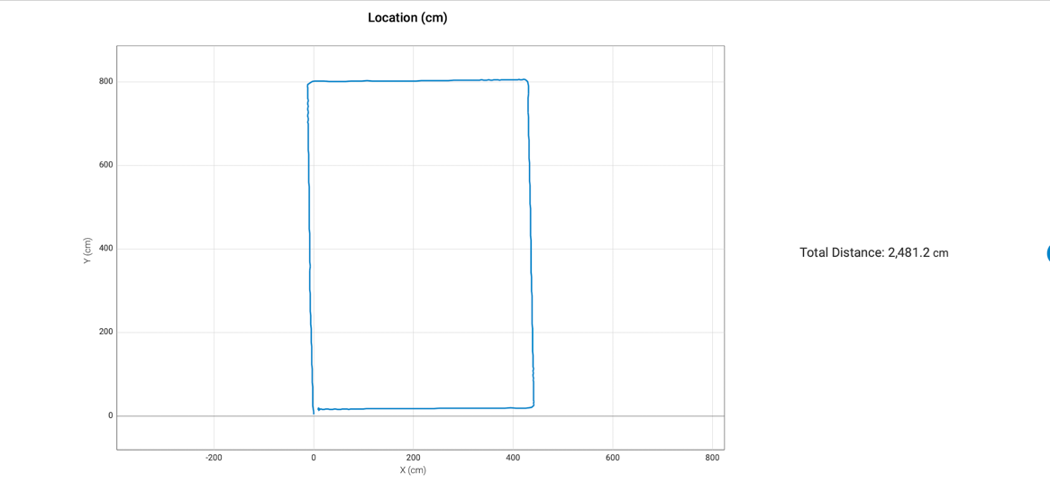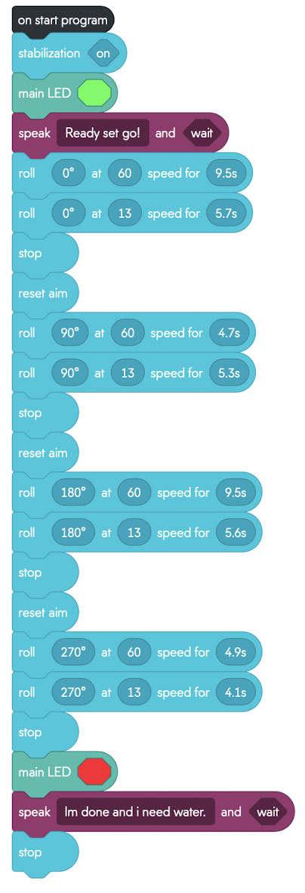

## Hardware

Sphero Sprk+ robot, Sphero robot charger, Apple MacBook Pro, iPhone

## Test Plan

Include a test plan showing all unit tests performed for this application, include test rational, test date, staff member, pass/fail status

| **Reason for Test Case** | **Test Date** | **Expected Output** | **Observed Output** | **Staff Name** | **Pass/Fail** |
| --- | --- | --- | --- | --- | --- |
| Align robot | 3/6/2023 | To move forward | It moved forward | Alex | Pass |
| Ensure proper turning | 3/6/23 | To turn right (90o) on blue line | Turned right (90o) on blue line | Alex | Pass |
| Ensure alignment after turns | 3/6/2023 | Follow blue line after right turn | Did not follow blue line after turn | Daniel | Fail |
| Align robot | 3/6/2023 | Follow blue line after right turn | Followed blue line after turn | Daniel | Pass |
| Ensure proper turning and timing | 3/6/2023 | Turn right again, following blue line | Did not follow blue line | Alex | Fail |
| Ensure proper turning and timing | 3/6/2023 | Turn right again, following blue line | Did not follow blue line | Alex | Fail |
| Ensure proper turning and timing | 3/6/2023 | Turn right again, following blue line | Followed blue line | Alex | Pass |
| Align robot | 3/6/2023 | Follow blue line after turning | Followed blue line | Daniel | Pass |
| Ensure proper turning and timing | 3/6/2023 | Turn right on blue line | Did not turn right | Alex | Fail |
| Ensure proper turning and timing | 3/6/2023 | Turn right on blue line | Turned right on blue line | Alex | Pass |
| Align robot | 3/6/2023 | Follow blue line | Followed blue line | Daniel | Pass |
| Ensure timing | 3/6/2023 | Stop in yellow square | Did not stop | Daniel | Fail |
| Ensure timing | 3/6/2023 | Stop in yellow square | Stopped in yellow square | Daniel | Pass |
| Functionality | 3/9/2023 | Flash green before movement | Flashed green | Alex | Pass |
| Functionality | 3/9/2023 | Say, “Ready, set, go!” after green light. | Said, “Ready, set, go!” after green light. | Alex | Pass |
| Functionality | 3/9/2023 | Turn red when finished moving | Turned red following last stop | Alex | Pass |
| Functionality | 3/9/2023 | Say, “I’m done, and I need water,” following red light. | Said, “I’m done, and I need water,” following red light. | Daniel | Pass |
| Full run | 3/9/2023 | Run full course successfully | Did not run full course successfully | Alex/Daniel | Fail |
| Full run | 3/9/2023 | Run full course successfully | Ran full course successfully | Alex/Daniel | Pass |

## Task List/Gantt Chart



## Staffing Plan

Insert a chart/table that depicts the roles and responsibilities of each team member that worked on this project.

| Name | Role | Responsibility | Reports To |
| --- | --- | --- | --- |
| Daniel Trocchia | Developer | Participate in various tasks regarding the success of the project. | Alex Kalina |
| Alex Kalina | Developer | Design and implement block code necessary to run the robot | Daniel Trocchia |